Project One

DAT 475

Southern New Hampshire University

Catherine Taft

5/15/23

**Problem Statement**

The situation being addressed here is an electronics factory in Tijuana, Mexico which is experiencing a high number of defects, specifically related to the assembly of circuit boards. The increase in defects is happening at the same time that an overall increase in demand is requiring more output from the factory. While the products all go through a Quality Control (QC) inspection after production and before moving on to assembly, it appears that the increase in defects along with the increase in product is causing more of them to slip through the QC process. This is causing performance problems in the products after assembly, but correcting the problems and repairing the items after assembly is ultimately cost- and resource-prohibitive.

Because the company needs to comply with the IPC-A-610E manufacturing standard, they are putting together a project that aims to correct these problems, with two outcomes: a 20% reduction in welding defects, and a 20% increase in production line capacity without an increase in defects. It’s important that these goals are attained in order for the company to continue successfully, and meet the increased demand from their clients without wasting resources correcting unnecessary problems. As it is currently, this level of defective product is not conducive to business success, so the root causes need to be identified and the process adjusted in a way that solves these issues.

**Most Significant Causes of Defects**

We have been given data for the factory as a whole, as well as three individual board models. We’ve constructed Pareto charts for all four of these datasets. Pareto charts are based on the Pareto Principle, which states that 80% of the problems come from 20% of the causes (Kenton, 2023). These charts consist of a bar graph that sums the frequency of occurrence of whatever problem is being analyzed, while the superimposed line chart represents the cumulative percentage of the total occurrences at each bar.

The charts will be included in the following section, but to summarize: if we look at the leading issue on all three models, we can see that it’s soldering by a fairly wide margin. Either solder bridge and excessive solder are the primary defect for all three, and then if we look at the facility as a whole, those are the top two defects. Then if we continue down the charts, we see that the remainder of the significant defects are component issues. These are issues where the components are damaged, missing, or incorrectly applied somehow. The following section will examine these results by board model.

**Root Cause Analysis – Pareto Charts**

Below we can see the four Pareto charts for the full factory, model 595407-XXX-00, model 595481-00X-00, and model 595310-001-00.

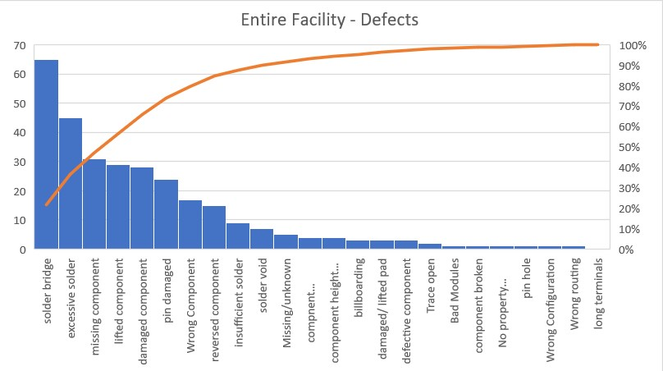

We can see here for the full factory that solder bridge and excessive solder are the leading two defects, and the remaining significant ones below the 80% mark are missing, lifted, and damaged component, pin damaged, and wrong component. So as mentioned in the summary, we have soldering and component quality issues here.

Next we can examine each model individually.

For this model again we have a soldering defect, specifically solder bridge as the leading issue, and then a series of component quality issues – lifted component, wrong component, pin damaged, and missing component. We see excessive solder noticeably below that here, followed by two more component issues. After that they become less relevant, but it’s worth noting that a large number of issues are contained within the 80% frame here.

This model again has solder bridge as the main defect, and the others are nowhere near as significant, but missing component, lifted component, and damaged pin are worth noting, even though they’re less than half as frequent as solder bridge defects.

The last model has excessive solder as the primary defect, with solder bridge as the second most significant, although with half the frequency. Damaged component and damaged pin are the other two contained within the 80%.

We can see that the results of the Pareto charts for the individual models make sense against the chart for the entire facility. As stated before, solder issues are the leading problem, which is reflected in the overall facility chart, and the remainder of the severe issues are component-related, whether damaged pieces or incorrectly assembled. This indicates that the soldering line and the assembly line need further inspection, and that we should narrow our root cause analysis to these parts of the production line. There is something happening in these two departments that is leading to an unsatisfactory quality of output.

**Root Cause Analysis – Fishbone Chart**

Based on the insights gained from the above information, we conducted a tour of the facility and employee interviews with the aim of investigating the management, as well as the assembly line and the soldering line, and how these departments are integrated into the rest of the company and production process. Below is the resulting fishbone diagram describing the contributors that we identified for the problem at hand:

To address these one at a time, we can begin with the People category. After interviewing employees, we discovered three troubling factors that seem to contribute to a lower standard of work. The first is inadequate training; new employees are put through a very brief training process where they’re only partially supervised, as the people training them have their own responsibilities and throughput requirements. This relates to the second issue which is that staffing is insufficient given the current production goals of the company. While demand has increased, they have not sufficiently hired new staff to meet that demand. Lastly, and again related, everyone seems very overworked. Fatigue leads to mistakes.

Under Process we found that employees were provided with insufficient process documentation. Standard up to date procedures and job roles as related to those procedures were poorly documented and not clearly defined. This was particularly an issue with the assembly line, to the point where it warrants its own subtopic in the chart. Related to this, we also found that there was a lack of standardization in work practice. Processes were not clearly documented, so employees were not using uniform techniques or using the same standards to report issues, leading to inconsistency and confusion.

For Materials, we found that due to cost reasons, the company had begun using lower quality materials, including solder and pins, that are prone to easily being damaged. Additionally, certain components and materials that require temperature control were not protected from the heat and humidity of Tijuana, and instead were stored out in the open. Several employees also complained that things were frequently mislabeled. Upon speaking with QC and Purchasing, we also discovered that because the company had switched to less reputable vendors as a cost-saving measure, there was a high amount of defective product coming in from the materials vendors. Most of this was caught before being moved out to the relevant lines, but it’s likely that some is slipping through due to overwork, undertraining and understaffing.

Last, and very unfortunate, we found a lot of problems with the management itself. The core issue was really a lack of leadership, which can be demonstrated through the poor training and management of staff. But we also found inconsistent feedback, so employees didn’t know when they were making mistakes, as well as an overall lack of employee empowerment, where employees didn’t even feel comfortable bringing up issues to management, for fear of reprisals or simply being ignored.

In all, we think these items within these four categories are the primary issues leading to the unusual level of bad quality product coming out of the factory, and in order to begin to meet the adjusted quality goals put forward by the company, these should be addressed immediately.

Resources

Kenton, W. (2023, January 2). *What is pareto analysis? how to create a pareto chart and example*. Investopedia. https://www.investopedia.com/terms/p/pareto-analysis.asp